TrelloLink:https://trello.com/invite/b/6992ee00c2dcff49cf1220ff/ATTI8f032d102407723a1a7884414f8e7132894A1415/pse-group-project
GitHub Link: https://github.com/saadsgit/PSE-Group-Project
Initial Product Backlog:
- Create Login and Register Function
- Create Function Showing for Students Showing Available Time Slots
- Create Appointment/Follow-Up Booking Function for Students
- Create Selectable List of Doctors/Practitioners when Booking Appointment/Follow-Up
- Create Section for Viewing Uploaded Online Report/Prescription for Students
- Create Function for Doctors/Practitioners to Be Able To View Their Daily Or Weekly Appointment Timetables
- Create Function for Doctors/Practitioners to Be Able to Write and Upload Online Reports/Prescriptions
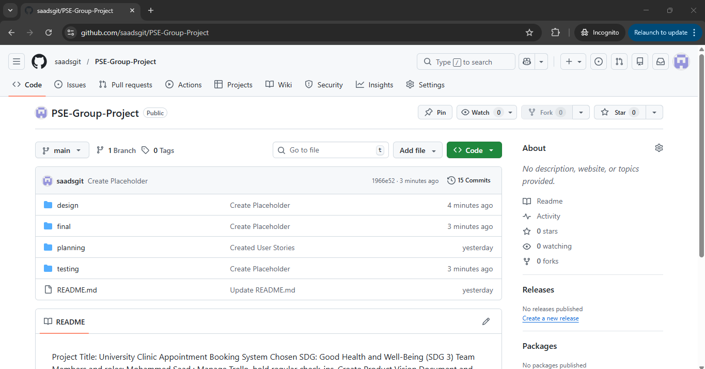
- Create Function for Doctors/Practitioners to Be Able to View Patients Past Medical History Records/Appointments
- Create Functions that Check Whether The Student Received Care On Time
